# Part 1: Test Cases:

TDD Test Cases for gradient, distance and equation of line between two points:

|  |  |  |  |  |  |  |  |  |  |
| --- | --- | --- | --- | --- | --- | --- | --- | --- | --- |
| S.N | Test Case Description | Input | | | | Expected Output | | | Remarks |
| **X1** | **Y1** | **X2** | **Y2** | **Gradient**  **(y2-y1)/ (x2-x1)** | **Distance**  **√(x2-x1)2 –(y2-y1)2** | **Equation**  **y-y1=m(x-x1) or**  **y=mx +c** |  |
| 1 | User enters the coordinates A(0,0), B(0,0) | 0 | 0 | 0 | 0 | 0 | 0 | 0 |  |
| 2 | User enters the coordinates A(1,1), B(1,1) | 1 | 1 | 1 | 1 | unidentified | 0 | Y=0 |  |
| 3 | User enters the coordinates A(-2,1), B(-1,1) | -2 | 1 | -1 | 1 | 1 | 0 | Y=1 |  |
| 4 | User enters the coordinates A(4,3), B(6,7) | 4 | 3 | 6 | 7 | 2 | √20 | Y=2x - 5 |  |
| 6 | User enters the coordinates A(0,0), B(0,0) | 2 | 4 | 4 | 6 | 1 | √8 | y = x + 2 |  |

# Part 2: Program developing screenshots:

**Step 1**: The project PRT452Assignment01 has been created and the package com.dipakbhattarai.learn is created.

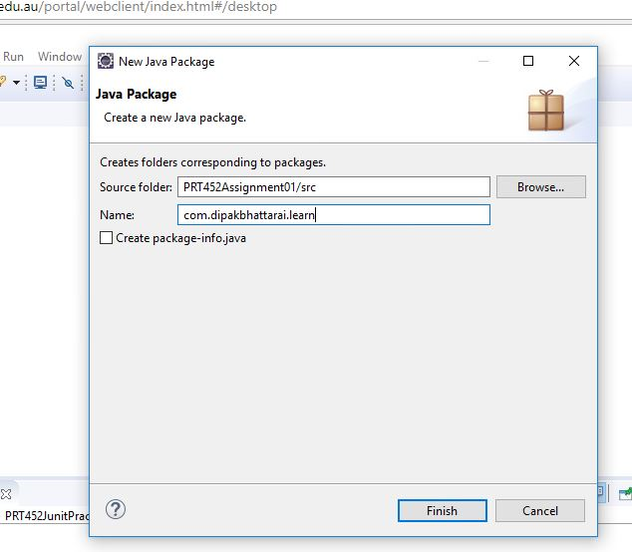

**Step 2**: The Interface Gradient is created. Similarly, the interfaces Distance and Equation are also created.

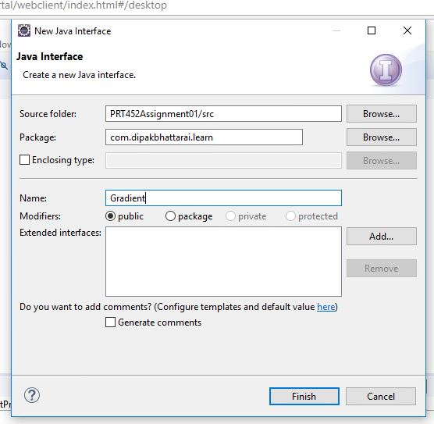

**Step 3**: The interfaces are created with the methods with their respective parameters.

*Interface1: Gradient and its method with parameters.*

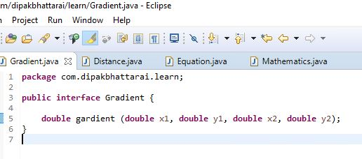

*Interface2: Distance and its method with parameters.*

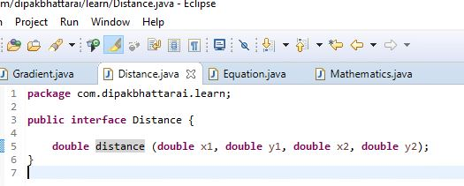

*Interface3: Equation and its method with parameters*.

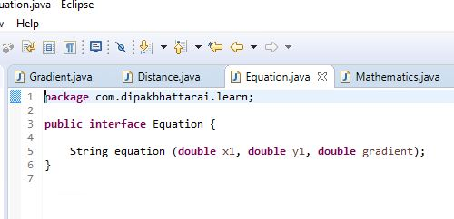

**Steps 4**: The java file "Mathematics.java" is created and the three interfaces are also implemented as shown in the picture:

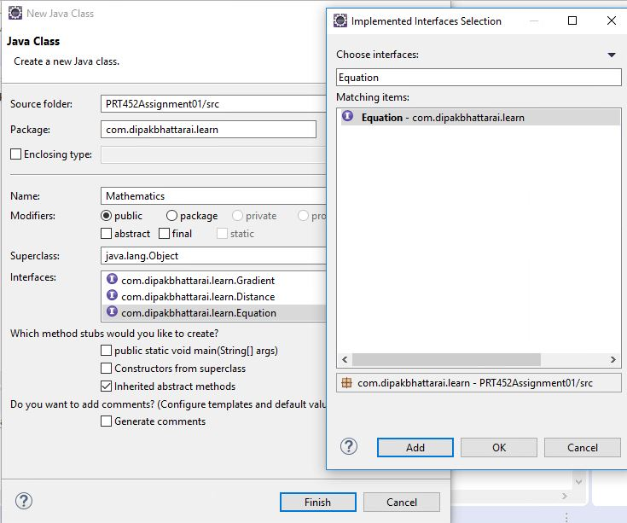

Output: The class Mathematics.java is created with its methods implemented from the interfaces

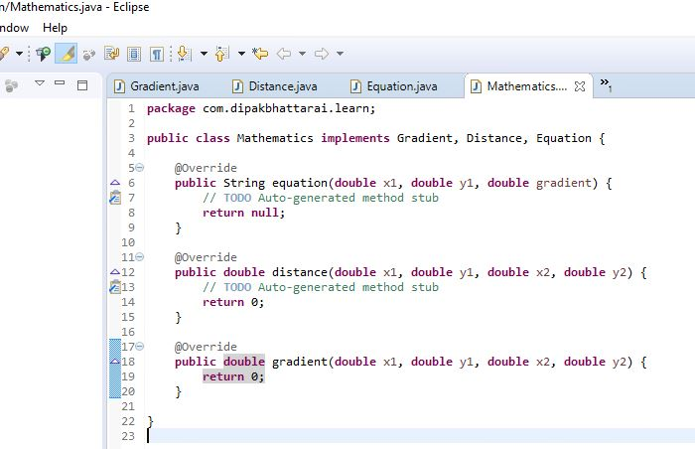

**Steps 5**: Creating folder testcases in order to separate the test file.

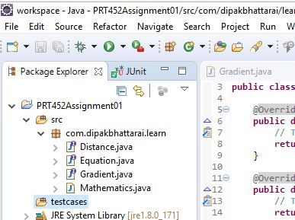

**Steps 6**: Creating the JuntTesting of the file Mathematics.java

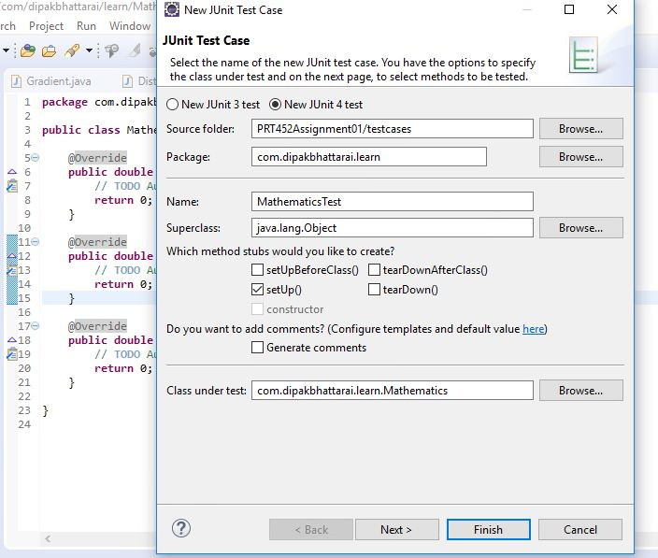

The follow picture shows the JunitTesting of the methods gradient, distance and equation:

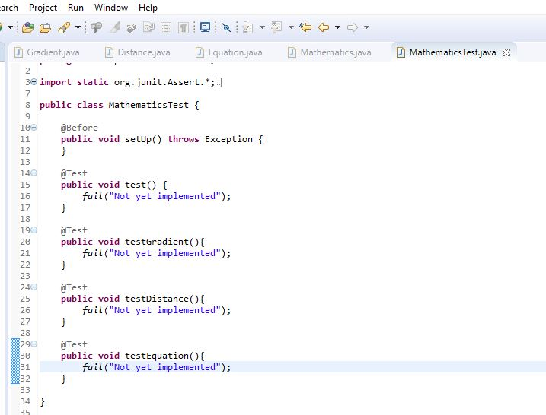

**Steps 7**: The testing fail showing the unmatched result.

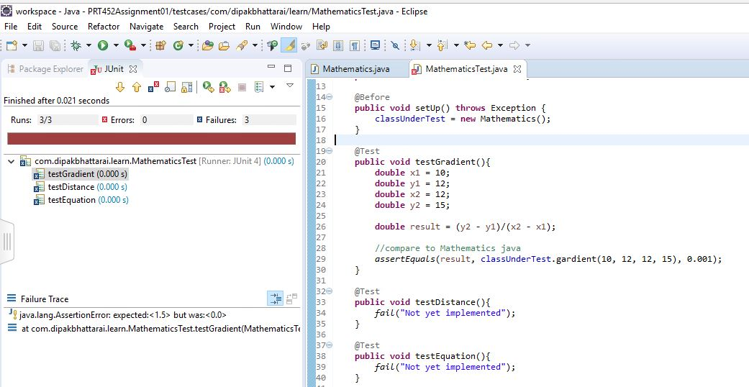

**Steps 8**: After implementing the codes the test is finally passed.

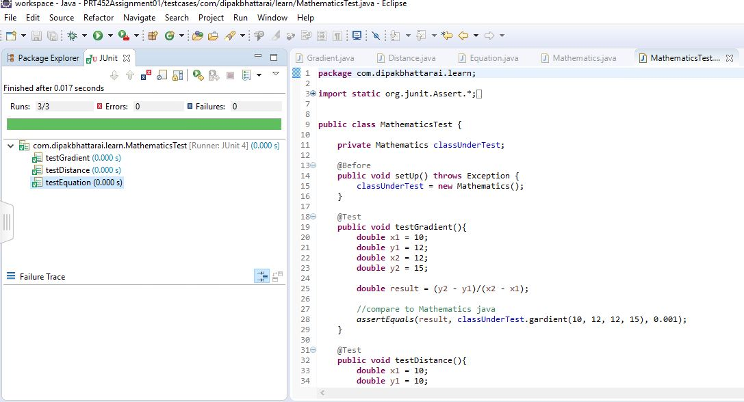

**Steps 9:** The final output of the program when user enters the two points.

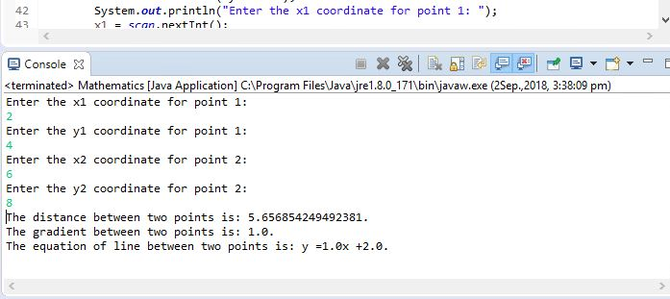

**Steps 10**: Creating the github repository for the assignment.

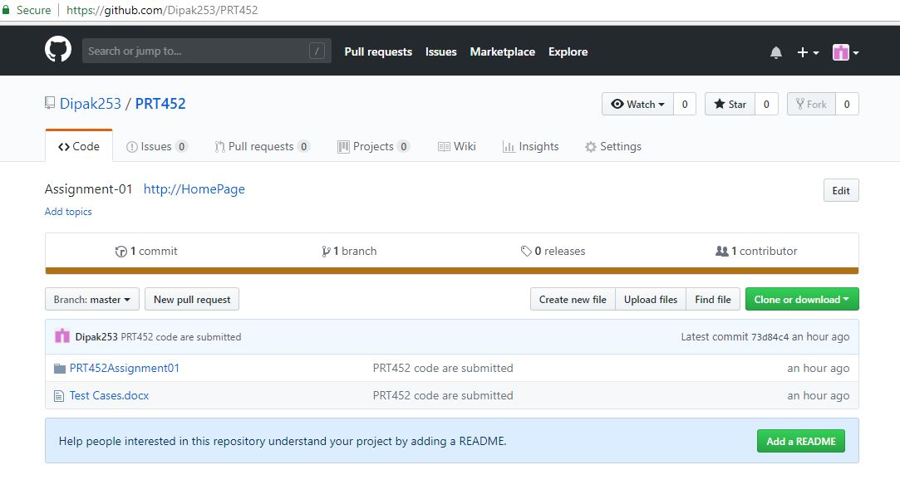

# Part 3: Code Smells

The five issues related to code smells are identified and the solution for them are discussed below as:

1. **Lazy Class**: Creating a class costs money. If the class which is not doing enough should be eliminated.

*Solution:*

* **Collapse Hierarchy**: It will collapse all the subclasses that aren’t doing enough.
* **Inline Component**: The useless components should be subjected using this method.

1. **Temporary Field**: An object needs its variables to be instantiated but sometimes some variables are only set for certain circumstances. Such code is difficult to understand.

*Solution:*

* **Extract Component**: It helps to collect all the concerns variables in the component.
* **Introduce Null Object**: It helps to eliminate conditional code and create an alternative component for invalid variables.

1. **Middle Man**: Sometimes the internal details of objects are encapsulated.

*Solution:*

* **Move Method** and **Move Field**: This methods are used to move features out the middle man into the other objects making the middle man empty.

1. **Large Class:** In large class, there are number of objects and its variables but all these variables are not be used at all.

*Solution:*

* **Extract Component**: It helps to bundle up the variables and
* **Extract subclass**: If the subset of variables are constant then Extract subclass can be used to overcome this problem

1. **Duplicated code:** It means repetitive use of the code in a program which is not a good practice.

*Solution:*

* **Extract Method:** This method is used to separate the similar codes and invoke the code from other place.